Winnie the Pooh on Friends and Friendship
by A.A. Milne–
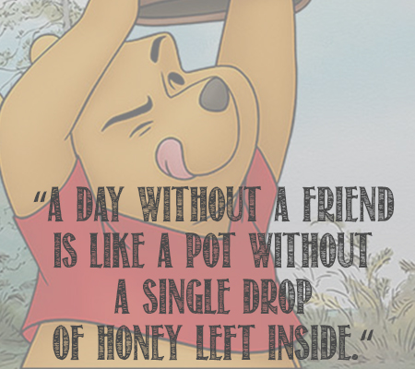
If you live to be a hundred, I want to live to be a hundred minus one day so I never have to live without you.
Promise me you'll always remember: You're braver than you believe, and stronger than you seem, and smarter than you think.
You can't stay in your corner of the Forest waiting for others to come to you. You have to go to them sometimes.
It is more fun to talk with someone who doesn't use long, difficult words but rather short, easy words like "What about lunch?"
Piglet noticed that even though he had a Very Small Heart, it could hold a rather large amount of Gratitude.
“I wonder what Piglet is doing," thought Pooh.
"I wish I were there to be doing it, too.”
Why did you do all this for me?' he asked. 'I don't deserve it. I've never done anything for you.' 'You have been my friend,' replied Charlotte. 'That in itself is a tremendous thing.” ― E.B. White, Charlotte's Web
“What is a friend? A single soul dwelling in two bodies.” ― Aristotle
I think if I've learned anything about friendship, it's to hang in, stay connected, fight for them, and let them fight for you. Don't walk away, don't be distracted, don't be too busy or tired, don't take them for granted. Friends are part of the glue that holds life and faith together. Powerful stuff.― Jon Katz
Friendship is the hardest thing in the world to explain. It's not something you learn in school. But if you haven't learned the meaning of friendship, you really haven't learned anything. ― Muhammad Ali
“How many slams in an old screen door? Depends how loud you shut it. How many slices in a bread? Depends how thin you cut it. How much good inside a day? Depends how good you live 'em. How much love inside a friend? Depends how much you give 'em.”
― Shel Silverstein
These four should be understood as warm-hearted friends:
- One who is a helpmate; guarding and protecting, a refuge in danger, giving more than is asked.
- One who is the same in happiness and sorrow; sharing and guarding confidences, remains a friend when things are bad, giving of themselves.
- One who gives good counsel; refrains from evil, encourages us to do good, informs us what is unknown of oneself, who is a good example.
- One who sympathizes; rejoices in prosperity and not misfortune, will not listen to or spread gossip, speaks well of their friend.
Adapted from the Sigalovada Sutta:
The Layman’s Code of Discipline
(Digha Nikaya, No. 31)
There is nothing better than a friend, unless it is a friend with chocolate. ― Linda Grayson

